**ASSIGNMENT COVER SHEET**

|  |  |  |  |
| --- | --- | --- | --- |
| **Student’s name** | (Family name)  Cui  Lakhani  Saranu  Dsouza | (Given names)  SiChen  Aryan  Sri Sravanth Sai  Oriana | |
| **ID number** | 33735328  34104607  34165665  31988989 | **Phone** | 401726230  0478470474  0422966627  0411224905 |
| **Unit name** | Applied Investment | **Unit code** | BFF5220 |

|  |  |  |  |
| --- | --- | --- | --- |
| **Title of assignment** | **Financial Data Analysis and Simulated Stock Trading** | | |
| **Lecturer/tutor** | Dr Viet NGA CAO | | |
| **Is this an authorised group assignment?**  **Yes  No**  If this submission is a group assignment, each student must attach their own signed cover sheet to the assignment. | | | |
| **Has any part of this assignment been previously submitted as part of another unit/course?**  **Yes**  **No** | | | |
| **Tutorial/laboratory day & time** | | 2.00pm-3.00pm Friday | |
| **Due date 06/10/2023** | | | **Date submitted 08/10/2023** |

All work must be submitted by the due date. If an extension of time to submit work is required, a [Special Consideration Application (In-semester Assessment Task)](http://www.monash.edu/__data/assets/pdf_file/0006/277152/in-semester.pdf) must be submitted.

**Has an extension been approved?  Yes  No If yes, please give the new submission date ….…/..…./…….**

Please note that it is your responsibility to retain copies of your assessments.

|  |
| --- |
| ***Intentional plagiarism or collusion amounts to cheating under Part 7 of the*** [***Monash University (Council) Regulations***](http://monash.edu/legal/legislation/current-statute-regulations-and-related-resolutions/)***.***  **Plagiarism**: means taking and using another person’s ideas or manner of expressing them and passing them off as one’s own. For example, by failing to give appropriate acknowledgement. The material used can be from any source (staff, students or the internet, published or unpublished works).  **Collusion**: means unauthorised collaboration with another person on assessable written, oral or practical work and includes paying another person to complete all or part of the work.  Where there are reasonable grounds for believing that intentional plagiarism or collusion has occurred, this will be reported to the Chief Examiner, who may disallow the work concerned by prohibiting assessment or refer the matter to the Associate Dean Teaching and Learning. |

|  |
| --- |
| **Student Statement:**   * I have read the University’s [Student Academic Integrity Policy](http://www.policy.monash.edu/policy-bank/academic/education/conduct/student-academic-integrity-policy.html) and the University’s [Student Academic Integrity: Managing Plagiarism and Collusion Procedures](http://www.policy.monash.edu/policy-bank/academic/education/conduct/student-academic-integrity-managing-plagiarism-collusion-procedures.html). * I understand the consequences of engaging in plagiarism and collusion as described in [Part 7 of the Monash University (Council) Regulations](http://monash.edu/legal/legislation/current-statute-regulations-and-related-resolutions/). * I have taken proper care of safeguarding this work and made all reasonable effort to ensure it could not be copied. * I acknowledge that the assessor of this assignment may for the purposes of assessment, reproduce the assignment and:  1. provide to another member of faculty; and/or 2. submit it to a plagiarism checking service; and/or 3. submit it to a plagiarism checking service which may then retain a copy of the assignment on its database for the purpose of future plagiarism checking.  * I certify that I have not plagiarised the work of others or participated in unauthorised collaboration when preparing this assignment.   *Signature ....SiChen Cui.................................................................................................. Date……………8/10/2023*  *Signature ....Aryan Lakhani.................................................................................................. Date……………8/10/2023*  *Signature ....Sri Sravanth Sai Saranu......................................................................................... Date……………8/10/2023*  *Signature ....Oriana Dsouza.................................................................................................. Date……………8/10/2023* |
| **Privacy Statement**  The information on this form is collected for the primary purpose of assessing your assignment. Other purposes of collection include recording your plagiarism and collusion declaration, attending to course and administrative matters and statistical analyses. If you choose not to complete all the questions on this form it may not be possible for Monash University to assess your assignment. You have a right to access personal information that Monash University holds about you, subject to any exceptions in relevant legislation. If you wish to seek access to your personal information or inquire about the handling of your personal information, please contact the University Privacy Officer: [privacyofficer@adm.monash.edu.au](mailto:privacyofficer@adm.monash.edu.au) |

Updated: Feb 2017

**Business Report**

**Financial Data Analysis and Simulated Stock Trading**

**Group 10**

Aryan Lakhani, SiChen Cui, Oriana Dsouza, Sri Sravanth Sai Saranu

Master of Advanced Finance (B6003), Monash University

BFF5220: Applied Investment(S2-2023)

Prof. Viet Cao

October 6th, 2023

**Table of Contents**

**1.** **Introduction** 5

**2.** **Literature review** 6

*1.1 Size and Momentum effects and its existence.* 6

*1.2 Size and Momentum across different markets.* 8

**3.** **Data Verification and Classification** 11

**4. Back Testing of Trading Strategies** 14

**Size Strategy** 14

**Momentum Strategy** 16

**5. Trading Details and Analysis** 21

Trading details 21

6. Conclusion 25

**7. References** 28

# **Introduction**

This report aims to analyse and validate existing financial theories. Within a given scope of stocks, various models are applied to predict their returns, including the Capital Asset Pricing Model, Fama and French’s 3-factor model, and Fama and French’s 5-factor model. In the portfolio construction process, historical data on stock returns are analysed using two distinct strategies: size strategy and momentum strategy. The feasibility of these strategies and the significance of explanatory variables are derived from a multiple linear regression model, through the use of back-testing historical time series data, observations are obtained on the expected stock return for a forecasted period and an analysis is presented. Practical trades are then executed using stock trading simulation software, adjusting portfolio positions through different market orders in order to justify the size or momentum trading strategy. After holding for approximately three weeks, long positions in stocks are sold, and short positions are acquired to close out the trades. The actual returns are then compared to the expected return observations, and an analysis is conducted based on the comparison.

# **Literature review**

## *1.1 Size and Momentum effects and its existence.*

Banz, (1980) examines the empirical relationship between the return and the total market value of NYSE common stocks. The research finds that smaller firms have higher risk-adjusted return, on average, than larger firms. This size effect has been in existence for less than forty years. According to Banz, the size effect does not hold a linear relationship with the market value. The main effect occurs for small firms when the return between average-sized and large firms is approximately the same. Chan, Chen, & HSIEH (1983) gathered historical data on stock return from a database that includes stocks of various sizes and categorized the stocks into different size groups based on market capitalization, including small-cap, mid-cap and large-cap, using regressions analysis to examine the relationship between firm size and stock returns. The paper confirmed the presence of the firm size effect, finding that smaller firms tended to outperform large firms in terms of stock returns.

Fama and French, (1992) used two variables including size and book-to market equity to capture the cross-sectional variation in the average stock returns associated with marketβ, size, leverage, book-to-market equity, and earnings-price ratios. They find that when unrelated to size, the relationship between marketβ and average return is flat, especially when marketβ is the only explanatory variable. We should thus take into consideration the size factor to predict stock returns. Carhart (1997) uses a substantial dataset of mutual funds data, including years of fund returns and portfolio information to construct a four-factor model that considers market risk, size effect, book-to-market ratio, and momentum effect. the author employs regression analysis to assess the fund’s selection ability and persistence while accounting for the influence of the four factors.

Fama & French (2015) employ a five-factor model to analyse and explain asset returns. The five factors include MKT, SMB, HML, RMW, and CMA. The paper conducted regression analyses to examine the relationship between these factors and asset returns, evaluating how well the five-factor model explains asset pricing. The study proposed a five-factor asset pricing model that extends the traditional CAPM and the Fama-French three factor-model. The five-factor model provides a better explanation for the cross-section of stock returns compared to the former two models. The introduction of the five-factor model has contributed to the ongoing research in asset pricing and the understanding of factors that drive stock returns.

Chan & Faff (1998) discuss the size effect among other factors in the context of the Australian stock market. They highlight the role of illiquidity as a factor in explaining the cross-section of asset returns, potentially alongside other factors like market risk or size.

As for the effect of the momentum factor, Jegadeesh and Titman’s (1993) report discovered evidence of significant returns on cross-sectional momentum investment strategies for investment horizons of 3-12 months. The research found strong evidence of a momentum effect. Stocks that have performed well in the recent past(winners) tend to continue performing well in the short term, while the stocks that have performed poorly (losers) tend to continue performing poorly. This suggests that there is a short-term persistence in stock price movements. The study demonstrates that trading strategies based on buying winners and selling losers can generate significant positive returns. In addition, the existence of the momentum effect challenges the efficient market hypothesis, which suggests that stock prices fully reflect all available information.

Docherty and hurst (2018) implement a momentum strategy, which involves forming portfolios of stocks based on past winners (high past return) and past losers (low past return), using the data on stock returns from various international equity markets, including both of the developed and emerging markets. The research finds that in markets where the investors exhibit a higher level of myopia (investors pay more attention to recent returns), the momentum trading strategy tends to be more profitable.

The momentum effect can be explained by behavioural bias. Barberis, Shleifer and Vishney (1998) indicate that the t single positive earning enables investors to underreact to the good news because of conservatism. The stock prices drifting upward. Leading to the momentum effect and post-earning Announcement drift. Dominated by representative bias, the investors incorrectly assume the positive return trend will continue, leading to the overreaction to good news. The reversal will happen in the long run.

Daniel, Hershleifer and Subrahmanyam (1998) believe that investors are subject to overconfidence and self-attribution biases. Self-attribution boosts investor confidence when new public information confirms the investor’s view. They continue to overreact to private information, leading to the momentum effect.

## *1.2 Size and Momentum across different markets.*

In assessing the existence of the size and momentum effects across different countries, and different markets. Akhtar, Ansari Ahmad, & Ansari Ahmad on the Indian stock market and the premium associated with the size effect, it demonstrated that there is in fact a negative relation between size and average return and a positive relationship between average return and value irrespective of size. There seems to be a strong size premium in the Indian stock market which is in contrast to the findings by Fama & French (2012). As the smaller firms assessed in the paper have higher slopes, it was deduced that smaller firms are riskier than bigger firms. As a conclusion, the research indicated that there is a significant size premium in Indian stock markets.

Carhart & Jialin (2002) focuses on the size effect, which involves comparing the returns of small-cap stocks to those of large-cap stocks, based on the stock returns from the German stock market. The research covers an extended time period to assess the persistence of the size effect in the German stock market. The study employs statistical analysis and regression techniques to investigate the persistence of the size effect, demonstrating the size effect, where small-cap stocks tend to outperform large-cap stocks, persists in the German stock market over an extended time period.

Chui & Wei (1998) uses the data on stock returns and firm characteristics from emerging stock markets in the Asia-Pacific region, including information on book-to-market ratios, firm size, and stock returns for a sample of companies in these markets. The study employs statistical analysis to investigate the relationship between the factors, using regression analysis to estimate the impact of these factors on stock returns during the turn-of-the-year period. The research finds both book-to-market ratios and firm size have significant effects on stock returns in Pacific-Basin emerging stock markets. stocks with higher book-to-market ratios (value stocks) tend to have higher returns during the turn-of-the-year period compared to growth stocks.

Nusret & Sinan Tan (2013), with the exception of Eastern Europe, examine the effects of value and momentum in 18 emerging stock markets and find that there is strong support for both in each of them. They examine size trends in value and momentum by building portfolios that are divided into groups based on book-to-market ratio, size, and lagging momentum. The returns for these portfolios are explained using three well-known factor models: the CAPM, the Fama-French three-factor model, and the Carhart four-factor model. This demonstrates the potential benefits for investors of using value and momentum strategies when investing in emerging markets.

West & Wang (2003) employ time-series analysis techniques to examine the degree of stock return predictability including momentum, using the historical data on stock returns from the Australian stock market. The study finds the ability of past stock returns to predict future returns is not constant but changes over time. The research suggests that market conditions, investor sentiment, and economic factors can influence the degree of stock return predictability.Chan & Faff (1998) discuss the size effect among other factors in the context of the Australian stock market. It highlights the role of illiquidity as a factor in explaining the cross-section of asset returns, potentially alongside other factors like market risk or size.

Matthias & Sailesh (2019)**,** talk about the impact of factor momentum on returns in the BRICS which is a group of five major emerging economies: Brazil, Russia, India, China, and South Africa. Their study's data came from Reuters and DataStream and referred to the BRICS emerging markets. The data was collected over an 11-year period, from January 2003 to December 2013. The study examined the momentum effects in the BRICS stock markets using accounting data. According to their findings, India's markets had the greatest momentum impacts, while China and Brazil showed significant medium- to long-term momentum profit. However, there were short-term momentum impacts in South Africa, and momentum portfolio returns on the Russian stock market were mostly minor.

Moskowitz & Grinblat (2017) used a large dataset of stock market data, including stocks from various industries and categorized stocks by industry to determine if momentum varied across different industries. The study found the momentum effects varied across different industries. In particular, stocks in some industries exhibit strong momentum, while those in other industries do not. The momentum phenomenon cannot be solely explained by industry effect. The research suggests that industry-specific information played a role in explaining differences in momentum effect across industries. And the market integration could impact momentum effects across different industries.

# **Data Verification and Classification**

The subjects selected for this experiment are 150 stocks chosen from a pool of 500 stocks. The database contains time series data for each stock from 29/06/2001 to 30/12/2022. When analyzing the descriptive statistics from both the group data and the overall data, measures such as the average return, minimum return, and median return turn out to be similar. The most notable differences in the descriptive statistics are in the maximum return and the standard deviation of the book value of the company. The discrepancy in the maximum return is due to not capturing specific stocks when filtering the data. Since the average returns are very similar, the impact of this outlier can be considered negligible. However, the difference in the standard deviation of the company's book value between the two databases may lead to biases when constructing portfolios.

**Table 3.1 - Data analysis between the group and the universe**



The database contains types of stocks classified into 9 industries based on SIC codes. These are 0 Agriculture, Forestry, and Fishing; 1 Mining and Construction; 2 & 3 Manufacturing; 4 Transportation and Communication; 5 Trade; 7 & 8 Services (Non-financial); and 9 Public Administration and Others. The expected relationship between the number of stocks in the overall database and the group database for each stock type is represented in Table 3.2.

**Table 3.2- The industry differences**

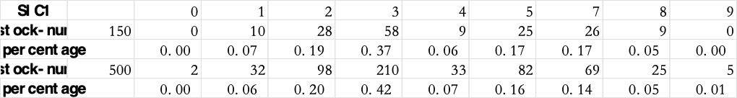

From the information above, it can be inferred that the proportion of the number of stocks in each industry to the total number of stocks is very similar. Analysed from an industry perspective, the local data is very representative of the overall data. However, compared with the overall data, the local data is clearly lacking with SIC codes 0 and 9. This data omission might cause biases in the construction of the global minimum variance portfolio based on investable stocks.

From the summary of the group data, we can draw the following conclusions:

1. Stock returns: The average return is 0.0134 with a median of 0.0088, suggesting a central concentration of returns for most stocks. The maximum return is 1.896, while the minimum return is -0.8665, indicating significant volatility in stock returns.
2. Company size: The average company size is 12,822.65, with a median of 1,319.42, indicating that a few very large companies are raising the average. The largest company size is 2,525,083.89, while the smallest is 1.38, indicating a wide range of company sizes. The standard deviation for company size is 69,324.73, highlighting the diversity in company sizes.
3. Operating profit rate: The average operating profit rate is 0.9744 with a median of 0.7343. The maximum value for the operating profit rate is 55.8125, while the minimum is -15, which might suggest that some companies are operating at a loss.
4. Book-to-market ratio: The average book-to-market ratio is 0.6215, with a median of 0.4539, suggesting a concentration in this range for most stocks.
5. Cumulative return: The average values for momentum over 3 months, 6 months, 9 months, and 12 months are 0.0188, 0.0386, 0.0587, and 0.0797, indicating that long-term momentum tends to be stronger than short-term momentum. The standard deviations increase progressively, suggesting that long-term momentum is more volatile.

From the analysis of the risk factor database, the following insights can be drawn:

**Risk-Free Rate (RF):** The average risk-free rate is lower than the median, and its standard deviation is relatively low, representing low volatility.

**Market Risk Premium (MRP):** The standard deviation of MRP is relatively high, suggesting that there is a significant uncertainty in the expected returns from the market over the risk-free rate. The average MRP is the highest among the factors.

**Size Factor (SMB):** SMB represents the return difference between small-cap and large-cap stocks. The standard deviation of SMB indicates that there is some volatility in the return difference between small and large firms.

**Value Factor (HML):** HML denotes the return difference between value and growth stocks. The standard deviation of HML shows that there is a certain degree of fluctuation in the return difference between value and growth stocks in the market.

**Profitability Factor (RMW) and Investment Strategy Factor (CMA):** Both have positive averages, and their standard deviations indicate a certain level of volatility in their returns.

**Momentum Factor (UMD):** UMD represents the return difference between stocks performing well and poorly based on their past returns. The standard deviation of UMD is the largest among these factors, signifying a significant volatility in returns.

# **4. Back Testing of Trading Strategies**

## **Size Strategy**

Based on the provided stock information, we first adopt a size strategy to analyse the stock returns. Specifically, we categorize the stocks into 5 groups based on their monthly MV (Market Value) ranking and calculate the equal-weighted return for each portfolio. The equal-weighted returns for each investment portfolio are as evidenced in Table 4.1.

**Table 4.1- Size Strategy**

|  |  |  |  |  |  |  |
| --- | --- | --- | --- | --- | --- | --- |
| Portfolios sorted by **MV** | SMALL | Portfolio 2 | Portfolio 3 | Portfolio 4 | BIG | SMALL minus  BIG |
| Mean Return (% pm) | 0.92 | 1.08 | 1.18 | 1.47 | 2.05 | 1.13 |
|  |  |  |  |  |  |  |
| Standard Deviation of Return (% pm) | 4.97 | 5.72 | 6.33 | 7.01 | 7.16 | 4.61 |
|  |  |  |  |  |  |  |
| CAPM beta | 1.04 | 1.15 | 1.23 | 1.27 | 1.25 | 0.21 |
| p-value | 0.00 | 0.00 | 0.00 | 0.00 | 0.00 | 0.05 |
|  |  |  |  |  |  |  |
| CAPM alpha | 0.17 | 0.26 | 0.32 | 0.58 | 1.17 | 0.90 |
| p-value | 0.76 | 0.08 | 0.09 | 0.26 | 0.00 | 0.17 |
|  |  |  |  |  |  |  |
| FF3 alpha | 0.17 | 0.22 | 0.25 | 0.48 | 1.10 | 0.83 |
| p-value | 0.09 | 0.07 | 0.40 | 0.16 | 0.00 | 0.11 |
|  |  |  |  |  |  |  |
| FF5 alpha | 0.06 | 0.12 | 0.14 | 0.34 | 1.11 | 0.95 |
| p-value | 0.57 | 0.35 | 0.26 | 0.02 | 0.00 | 0.03 |
|  |  |  |  |  |  |  |
| FF6 alpha | 0.06 | 0.14 | 0.16 | 0.37 | 1.16 | 0.10 |
| p-value | 0.55 | 0.26 | 0.20 | 0.01 | 0.00 | 0.01 |

Generally, based on the size effect theory, smaller stocks might have higher expected returns compared to larger stocks. Because smaller stocks are regarded as riskier assets and hence require a higher expected return to compensate for this risk. Based on the outcome which is listed above, the size effect really existed. The average return increases as the company size grows, this aligns with the Fama and French theory. In addition, it can be observed that as size increases, the CAPM beta also increases. This implies that larger stocks have a relatively higher market risk exposure. The returns for large stocks still exceed expectations, which means that other factors might play a role in it. The size effect plays an important role in explaining the cross-sectional variation in stock returns. The size factor is still significant even if we control the market factor. The difference between the results reported by Fama and French (1992) and our research can be explained by the differences in the data sample and time frame.

The global financial markets in the previous years since the 1992 report has undergone many changes, which might have influenced the size effect, Many research papers find that the size effect is decreasing over the time. With the development of technology and the increase in market players, markets can be more efficient, which can account for the weakening of the size effect. Additionally, as the size effect became widely recognized, the existence of arbitrage can also decrease the size effect. Based on the data, the SMB group provides us with a positive alpha considering risk, and the p-values indicate that the positive alpha is reliable. If we create a portfolio following the size effect strategy, there is a possibility to earn a positive risk-adjusted return.

## **Momentum Strategy**

The momentum strategy involves grouping stocks based on their mom3, mom6, mom9, and mom12. Since the momentum strategy is a zero-sum investment, there is no deduction of the risk-free rate (rf) for returns. After grouping, the returns of the stocks are analysed using different economic models.

**Table 4.2 – Panel A – The 3 x 1 x 1 Momentum Strategy**

|  |  |  |  |  |  |  |
| --- | --- | --- | --- | --- | --- | --- |
| Portfolios sorted by **MOM3** | Loser | Portfolio 2 | Portfolio 3 | Portfolio 4 | Winner | Winner  minus  Loser |
| Mean Return (% pm) | 1.62 | 1.43 | 1.10 | 1.03 | 1.51 | -0.11 |
| Standard Deviation of Return (% pm) | 7.85 | 5.95 | 4.21 | 5.60 | 6.41 | 5.38 |
|  |  |  |  |  |  |  |
| CAPM beta | 1.17 | 1.09 | 1.09 | 1.16 | 1.43 |  |
| p-value | (0.00) | (0.00) | (0.00) | (0.00 | (0.00) |  |
|  |  |  |  |  |  |  |
| CAPM alpha | 0.68 | 0.26 | 0.31 | 0.61 | 0.63 | -0.15 |
| p-value | (0.27) | (0.12) | (0.04) | (0.05) | (0.00) | (0.02) |
|  |  |  |  |  |  |  |
| FF3 alpha | 0.62 | 0.20 | 0.27 | 0.56 | 0.56 | -0.17 |
| p-value | (0.00) | (0.08) | (0.02) | (0.00) | (2.26) | (0.60) |
|  |  |  |  |  |  |  |
| FF5 alpha | 0.53 | 0.09 | 0.09 | 0.42 | 0.61 | -0.02 |
| p-value | (0.40) | (0.06) | (0.39) | (0.35) | (0.86) | (0.94) |
|  |  |  |  |  |  |  |
| FF6 alpha | 0.51 | 0.10 | 0.10 | 0.44 | 0.71 | 0.09 |
| p-value | (0.83) | (0.38) | (0.36) | (0.15) | (0.00) | (0.76) |

**Table 4.2 – Panel B-The 6x 1 x 1 Momentum Strategy**

|  |  |  |  |  |  |  |
| --- | --- | --- | --- | --- | --- | --- |
| Portfolios sorted by **MOM6** | Loser | Portfolio 2 | Portfolio 3 | Portfolio 4 | Winner | Winner  Minus  Loser |
| Mean Return (% pm) | 1.47 | 1.30 | 1.12 | 1.27 | 1.52 | 0.04 |
| Standard Deviation of Return (% pm) | 6.45 | 5.27 | 5.46 | 6.02 | 8.09 | 5.68 |
|  |  |  |  |  |  |  |
| CAPM beta | 1.17 | 1.04 | 1.08 | 1.17 | 1.47 |  |
| p-value | (0.00) | (0.00) | (0.02) | (0.11) | (0.42) |  |
|  |  |  |  |  |  |  |
| CAPM alpha | 0.64 | 0.55 | 0.35 | 0.45 | 0.50 | -0.24 |
| p-value | (0.05) | (0.01) | (0.02) | (0.12) | (0.11) | (0.48) |
|  |  |  |  |  |  |  |
| FF3 alpha | 0.57 | 0.50 | 0.30 | 0.39 | 1.60 | -0.25 |
| p-value | (0.25) | (0.00) | (0.62) | (0.35) | (0.11) | (0.24) |
|  |  |  |  |  |  |  |
| FF5 alpha | 0.52 | 0.35 | 0.16 | 0.22 | 0.49 | -0.12 |
| p-value | (0.93) | (0.13) | (0.14) | (0.94) | (0.47) | (0.72) |
|  |  |  |  |  |  |  |
| FF6 alpha | 0.47 | 0.34 | 0.16 | 0.27 | 0.61 | 0.03 |
| p-value | (0.13) | (0.16) | (0.12) | (0.23) | (0.26) | (0.91) |

**Table 3.2 – Panel C – The 9 x 1 x 1 Momentum Strategy**

|  |  |  |  |  |  |  |
| --- | --- | --- | --- | --- | --- | --- |
| Portfolios sorted by **MOM9** | Loser | Portfolio 2 | Portfolio 3 | Portfolio 4 | Winner | Winner  Minus  Loser |
| Mean Return (% pm) | 1.46 | 1.17 | 1.27 | 1.21 | 1.58 | 0.12 |
| Standard Deviation of Return (% pm) | 6.23 | 5.11 | 5.44 | 6.15 | 8.59 | 6.16 |
|  |  |  |  |  |  |  |
| CAPM beta | 1.12 | 1.00 | 1.07 | 1.19 | 1.56 |  |
| p-value | (0.00) | (0.00) | (0.00) | (0.00) | (0.00) |  |
|  |  |  |  |  |  |  |
| CAPM alpha | 0.67 | 0.44 | 0.50 | 0.37 | 0.51 | -0.25 |
| p-value | (0.36) | (0.22) | (0.11) | (0.46) | (0.09 | (0.48) |
|  |  |  |  |  |  |  |
| FF3 alpha | 0.60 | 0.39 | 0.45 | 0.32 | 0.43 | -0.27 |
| p-value | (0.17) | (0.04) | (0.00) | (0.24) | (0.11) | (0.45) |
|  |  |  |  |  |  |  |
| FF5 alpha | 0.52 | 0.27 | 0.28 | 0.14 | 0.54 | 0.14 |
| p-value | (0.86) | (0.16) | (0.14) | (0.32) | (0.04) | (0.89) |
|  |  |  |  |  |  |  |
| FF6 alpha | 0.46 | 0.25 | 0.29 | 0.18 | 0.68 | 0.11 |
| p-value | (0.11) | (0.21) | (0.11) | (0.14) | (0.05) | (0.66) |

**Table 3.2 – Panel D – The 12 x 1 x 1 Momentum Strategy**

|  |  |  |  |  |  |  |
| --- | --- | --- | --- | --- | --- | --- |
| Portfolios sorted by **MOM12** | Loser | Portfolio 2 | Portfolio 3 | Portfolio 4 | Winner | Winner  Minus  Loser |
| Mean Return (% pm) | 1.32 | 1.35 | 1.15 | 1.24 | 1.63 | 0.30 |
| Standard Deviation of Return (% pm) | 6.06 | 5.26 | 5.34 | 6.05 | 8.74 | 6.21 |
|  |  |  |  |  |  |  |
| CAPM beta | 1.10 | 1.03 | 1.05 | 1.18 | 1.58 |  |
| p-value | (0.28) | (0.00) | (0.02) | (0.25) | (0.16) |  |
|  |  |  |  |  |  |  |
| CAPM alpha | 0.54 | 0.61 | 0.40 | 0.40 | 0.54 | -0.09 |
| p-value | (0.01) | (0.06) | (0.01) | (0.02) | (0.08) | (0.78) |
|  |  |  |  |  |  |  |
| FF3 alpha | 0.48 | 0.57 | 0.35 | 0.62 | 0.47 | -0.12 |
| p-value | (0.01) | (0.05) | (0.00) | (0.07) | (0.08) | (0.74) |
|  |  |  |  |  |  |  |
| FF5 alpha | 0.33 | 0.40 | 0.20 | 0.22 | 0.60 | 0.16 |
| p-value | (0.76) | (0.00) | (0.06) | (0.09) | (0.03 | (0.67) |
|  |  |  |  |  |  |  |
| FF6 alpha | 0.26 | 0.38 | 0.22 | 0.27 | 0.73 | 0.37 |
| p-value | (0.11) | (0.01) | (0.04) | (0.18) | (0.31) | (0.14) |

# **5. Trading Details and Analysis**

## Trading details

Based on the regression analysis data, the model's fit is worse compared to the size effect, which can be inferred from the Adjusted R square and p-values. Overall, whether we consider the three-month momentum cumulative return, six-month momentum cumulative return, nine-month momentum cumulative return, or twelve-month momentum cumulative return, adopting the momentum strategy cannot provide us with positive excess returns. Based on our database, model construction, and regression analysis, it appears that using a momentum strategy might not yield positive excess returns. The research has decided to adopt a size-based strategy for investment.

We sort the given stocks based on the latest stock mv. And then, we choose thirty stocks with relatively smaller mv. We divide the 30 stocks into 5 groups, buying the stocks in the small group, and selling the stocks in the large group. We adopt the Equal-value method constructing the long-short portfolio, holding the portfolio for four weeks.

|  |  |  |  |  |
| --- | --- | --- | --- | --- |
|  |  | **Table 4.1 - Trading details** | |  |
| **Name** | **Share price** | **No of Shares** | **Interest** | **Total Amount $** |
|  |  | LONG |  |  |
| MIND | 0.61 | 12994 |  | 7926.34 |
| ARTW | 2.43 | 3155 |  | 7666.65 |
| DXYN | 0.77 | 9956 |  | 7666.12 |
| SIF | 3.2 | 2396 |  | 7667.2 |
| MTEX | 11.5 | 690 |  | 7935 |
| NSYS | 10.13 | 793 |  | 8033.09 |
|  |  | SHORT |  |  |
| LYTS | 14.85 | 515 |  | 7647.75 |
| MCS | 15.01 | 514 |  | 7715.14 |
| BELFB | 46.03 | 166 |  | 7640.98 |
| CVLG | 45.41 | 168 |  | 7628.88 |
| ZEUS | 51.14 | 151 |  | 7722.14 |
| POWL | 79.97 | 95 |  | 7597.15 |
| Total Amount Spent | |  |  | 93342 |
| Interest Amount |  |  |  | 2332 |
| Transaction Cost |  |  |  | 230 |
| Buffer |  |  |  | 4000 |
| Remaining |  |  |  | 96 |

After we concluded our trading. We calculated the daily return and cumulative of each of the stocks as well as the real return during this period of time.

**Table 4.2 - Portfolio performance**

|  |  |  |  |  |  |  |
| --- | --- | --- | --- | --- | --- | --- |
|  | Long |  |  |  |  |  |
| stock | **ARTW** | **DXYN** | **MIND** | **MTEX** | **NSYS** | **SIF** |
| buying price | 2.43 | 0.77 | 0.61 | 11.5 | 10.13 | 3.2 |
| selling price | 2.27 | 0.55 | 0.4835 | 10.10 | 8.5 | 4.66 |
| Number of shares | 3155 | 9956 | 12994 | 690 | 793 | 2396 |
| T0 value | 7666.65 | 7666.12 | 7926.34 | 7935 | 8033.09 | 7667.2 |
| T1 value | 7161.85 | 5475.8 | 6282.599 | 6969 | 6740.5 | 11165.36 |
| Profit | -504.8 | -2686.1288 | -1643.741 | -966 | -1292.59 | 3498.16 |
|  |  |  |  |  |  |  |
|  | Short |  |  |  |  |  |
|  | **BELFB** | **CVLG** | **LYTS** | **MCS** | **POWL** | **ZEUS** |
| selling price | 46.03 | 45.41 | 14.85 | 15.01 | 79.97 | 51.14 |
| buying price | 48.35 | 44.97 | 16.52 | 15.82 | 83.07 | 51.19 |
| number of shares | 166 | 168 | 515 | 514 | 95 | 151 |
| T0 value | 7640.98 | 7628.88 | 7647.55 | 7715.14 | 7597.15 | 722.14 |
| T1 value | 8026.1 | 7554.96 | 8507.8 | 8131.48 | 7891.65 | 7729.69 |
| Profit | -385.12 | 73.92 | -860.05 | -416.34 | -294.5 | -7.55 |
| Portfolio profit | -5484.74 |  |  |  |  |  |
| **Total rate of return (%)** | **-5.9%** |  |  |  |  |  |

# 6. Conclusion

Compared with the Risk-free rate, our portfolio suffered a loss. The investing philosophy of our portfolio is based on the size effect which considers that small firms tend to earn a higher profit than big firms. But in actuality, the stocks which we selected to be the components of our portfolio suffered from a loss during the trading period. The loss of the stocks which we chose to short is smaller than the loss of the ones which we chose to long. We can observe this trend through the cumulative return plots below. The loss of the short position group ranges from 4-6%, while the loss of the long position group ranges from 6-8%. Constructing the portfolio only based on the size effect does not prove to be profitable in this case. The strength of the size effect can vary across different time periods, and regions and based on different market conditions. The following are potential reasons for this outcome.

1. Adaptive Market Hypothesis

The size effect has been found and proved to be true many years ago. This effect might diminish or reverse as stock market players begin to exploit known effects. Additional research might be required to understand the relevance of the size effect in current markets.

2. Market structure changes

With the evolution of the stock market and the advancements in technology, investor behaviour and market structures may naturally change. The previous effects would no longer hold relevance and validity.

3. Overconfidence

When the size effect is widely spread as being regarded as the secret to winning a positive return across different regions, the excessive number of size strategy investors might buy smaller cap stocks and short the big cap stocks overconfidence, expecting an abnormal return. This kind of excessive optimism and overconfidence might lead to an unreasonable stock price. If we keep using the size strategy in the market, the real return can be negative.

4. Mental accounting

Investors may view small-cap stocks and large-cap stocks as different mental accounts, assigning them distinct risk and return expectations. As time goes by and the stock market develops, this kind of expectation and bias might change, influencing the size effect.

In conclusion, It is important to realise that our evaluation period, which lasted only one month, might not give a complete picture of the impact of the size effect. Considering that over the period the market had a decline overall. Smaller equities, in particular, may suffer greater losses than their larger counterparts during such a market downturn. Therefore, it is possible that the size effect requires a longer evaluation period in order to completely express its potential benefits or the effect might require a market that is less turbulent and more reflective of the true investor belief rather than driven by negative investor sentiment. Additionally, a calmer market environment may better reveal the size effect's true potential benefits.

**Graph 1.1 - Visualization of the Short Portfolio**

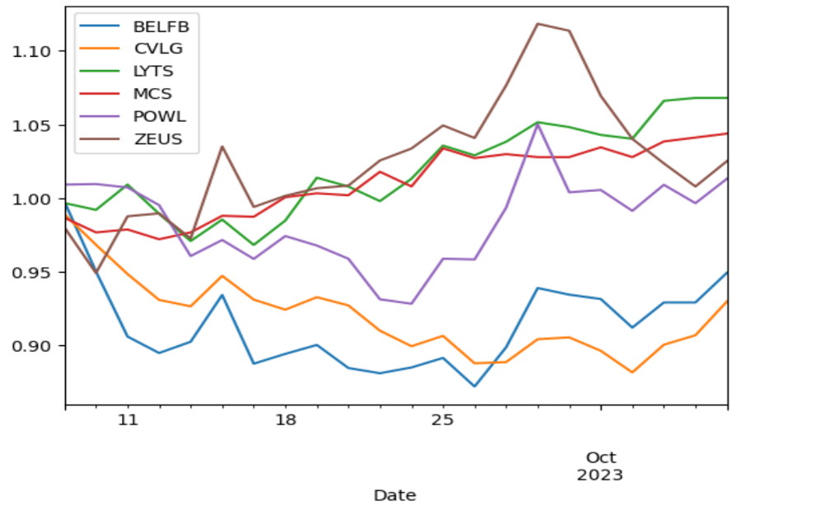

**Graph 1.2 - Visualization of the Long Portfolio**

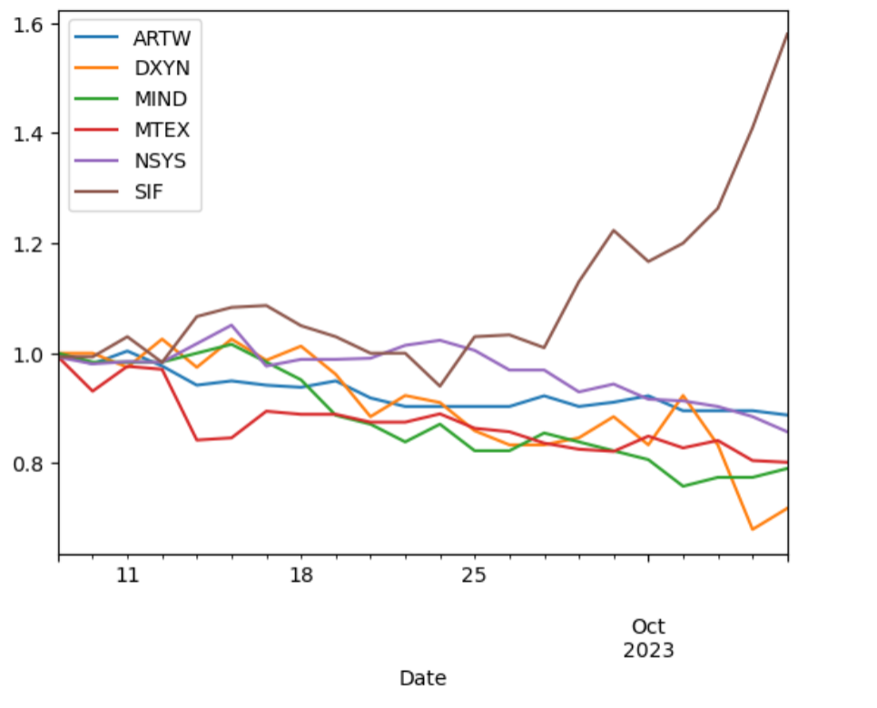

# **7. References**

*Banz, R. W. (September 1980). The relationship between returns and market value of common stocks. 16.*

FAMA, E.F. and FRENCH, K.R. (1992), The Cross-Section of Expected Stock Returns. The Journal of Finance, 47:427-465.

Carhart, M. M. (1997). On Persistence in Mutual Fund Performance. *The Journal of Finance*, *52*(1), 57–82.

*Chan, Howard and Faff, Robert W., Asset Pricing and the Illiquidity Premium. The Financial Review, Vol. 40, No. 4, November 2005*

*Jegadeesh, N., & Titman, S. (1993). Returns to Buying Winners and Selling Losers: Implications for Stock Market Efficiency. The Journal of Finance, 48(1), 65–91.*

*Docherty, P., & Hurst, G. (2018). Investor Myopia and the Momentum Premium across International Equity Markets. Journal of Financial and Quantitative Analysis, 53(6), 2465- 2490. doi:10.1017/S0022109018000431*

*Chui, C. W. A., & Wei, K. C. J. (1998). Book-to-market, firm size, and the turn-of-the-year effect: Evidence from acific-Basin emerging markets. Pacific Basin Finance Journal, 6(3-4), 275-293.*

*Carhart, M. M., Hualing, L., & Jialin, Y. (2002). The Persistence of the Size Effect: Evidence from the German Stock Market. Basu, S. (1977). Investment performance of common stocks in relation to their price earnings ratios. A test of market efficiency. Journal of Finance, 32.*

*Chan, K. C., Chen, N.-f., & HSIEH, D. A. (August 1983). An exploratory investigation of the firm size effect. 21.*

*Moskowitz, T.J. and Grinblat, M. (1999), Do Industries Explain Momentum. The Journal of Finance, 54: 1249-1290.*

*Fama and Kenneth R. French, 2015, Five-factor asset pricing model Eugene, journal of Financial Economics,2015, vol. 116, issue 1, 1-22*

*ASNESS, C.S., MOSKOWITZ, T.J. and PEDERSEN, L.H. (2013), Value and Momentum Everywhere. The Journal of Finance, 68: 929-985.*

*Barroso, P., & Santa-Clara, P. (2015). "Momentum has its moments."* [*Journal of Financial Economics (JFE), vol. 116, Issue 1, 2015, 111-120*](https://papers.ssrn.com/sol3/papers.cfm?abstract_id=2041429)

*Eugene F. Fama, Kenneth R. French, Common risk factors in the returns on stocks and bonds, Journal of Financial Economics, Volume 33, Issue 1, 1993, Pages 3-56, ISSN 0304-405X.*

*Fama, E., & French, K. R. (1992). The Cross-section of expected stock returns. Journal of finance, 47(2), 427-465.*

*Fama, E. F., & French, K. R. (2012). Size, value, and momentum in international stock returns. Journal of Financial Economics, 105.*

*Harvey, C.R., Liu, Y. and Zhu, H. (2016) and the Cross-Section of Expected Returns. The Review of Financial Studies, 29, 5-68.*

*Leland. (1999). Maximizing expected return for a given level of risk.*

*Litzenberger, Robert H, & Krishna, R. (1979). The effect of personal taxes and dividends on capital asset prices: Theory and empirical evidence. Journal of Financial Economics,*

*Matthias Nnadi & Sailesh Tanna (2019) Accounting analyses of momentum and contrarian strategies in emerging markets, Asia-Pacific Journal of Accounting & Economics, 26:4, 457-477.*

*Merton’s (1973). Intertemporal CAPM theory.*

*Nusret Cakici, F. J. F., Sinan Tan (2013). "Size, value, and momentum in emerging market stock returns." Emerging Markets Review 16 (2013) 46–65.*

*Rolf W. Banz, The relationship between return and market value of common stocks, Journal of Financial Economics, Volume 9, Issue 1,1981, Pages 3-18.*

*Wang, A. G. a. J. G. (2016). "The Trend Is Your Friend: Time-Series Momentum Strategies across Equity and Commodity Markets* " Review of Finance, 2017, 1557–1592.*

*Barberis, Nicholas, Andrei Shleifer, and Robert Vishny. 1998. “A Model of Investor Sentiment.” Journal of Financial Economics 49 (3): 307-343.*

*Daniel, K., Hirshleifer, D., & Subrahmanyam, A. (1998). Investor Psychology and Security Market under- and Overreactions. The Journal of Finance, 53(6), 1839–1885. http://www.jstor.org/stable/117455*